ASSIGNMENT - 1

**NAME** : KARTHIKEYAN M

**COLLEGE** : Sona College Of Technology

**Create circuit with Piezo alarm, PIR sensor, tmp sensor with below functionalities:**

1. Alarm should sound in one manner if temp is above 60 degree Celsius.
2. Alarm should sound with another frequency if motion is detected in PIR sensor.

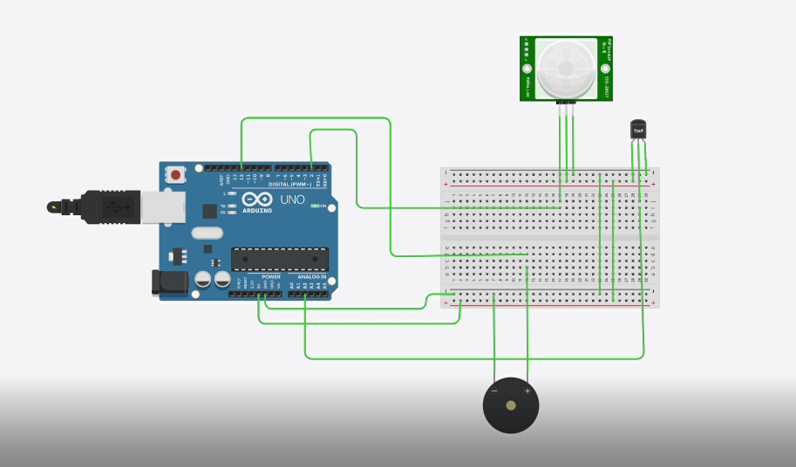

**ARDUINO UNO CODE:**

void setup()

{

Serial.begin(9600); pinMode(2,INPUT); pinMode(12,OUTPUT);

}

void loop()

{

int motion=digitalRead(2); if(motion==1){ Serial.println("Motion detected"); tone(12,10);

delay(1000); noTone(12); delay(1000);

}

else{

Serial.println("No motion");

}

double data=analogRead(A2); double n=data/1024;

double volt=n*5; double off=volt-0.5;

double temperature=off*100; Serial.print("Temperature data: "); Serial.println(temperature); if(temperature>60.00)

{

tone(12,100); delay(500); noTone(12); delay(500);

}

}

OUTPUTS

SIMULATION LINK :

<https://drive.google.com/file/d/1-vH1f0qdxVmulFWsWlF1I7JGgA4dsRet/view?usp=sharing>